JOINT APPLICATION FORM
FOR THE FOLLOWING SCHOLARSHIPS

KNIGHTS OF COLUMBUS COUNCIL 8096

JOHN ZIRKLE MEMORIAL

ST. ELIZABETH ANN SETON
LADIES AUXILIARY

LISA SICOLA MEMORIAL

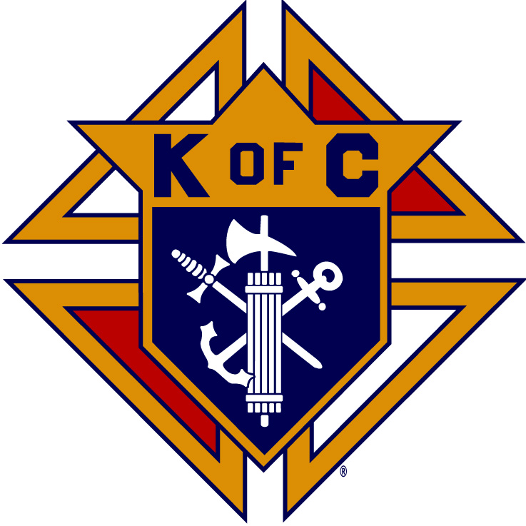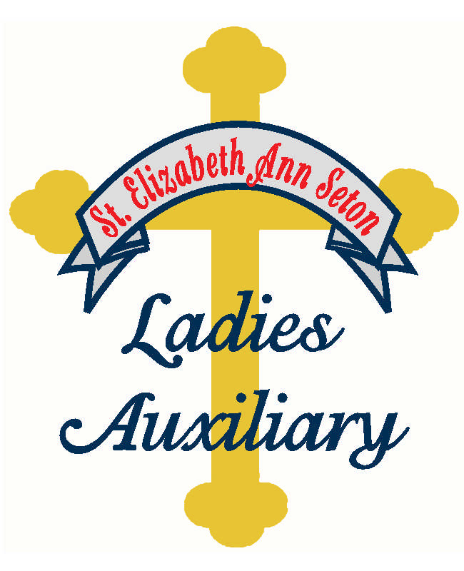

Knights of Columbus
Council #8096
St. Elizabeth Ann Seton Catholic Church
6646 Addicks-Satsuma Rd
Houston, Texas 77084

KNIGHTS OF COLUMBUS COUNCIL 8096
SCHOLARSHIP INFORMATION
PAGE 2 OF 6

GUIDELINES

- Two Knights of Columbus Council 8096 Scholarships will be awarded in the amount of $2,000 each
- Two John Zirkle Memorial Scholarships will be awarded in the amount of $2,000 each
- Two Ladies Auxiliary Scholarships will be awarded in the amount of $2,000 each
- One Lisa Sicola Memorial Scholarship will be awarded in the amount of $1,500
- Scholarship winners will be honored at our annual awards banquet and funds transferred when certain conditions are met
- Applicants will be considered for all scholarships described in this application, providing applicant meets eligibility requirements as described below; do not submit multiple applications
- Each applicant is eligible to receive only one of the scholarships described in this application

ELIGIBILITY REQUIREMENTS

KNIGHTS OF COLUMBUS COUNCIL 8096 SCHOLARSHIP

- Applicant shall be a graduating senior planning to pursue a post-secondary education at a university, community college or technical school in the fall of 2023
- Applicant shall be a member of St. Elizabeth Ann Seton Catholic Community, e.g., parents are registered as parish members, student attends Mass at SEAS, and is an active participant in the community life of SEAS

JOHN ZIRKLE MEMORIAL SCHOLARSHIP and
LADIES AUXILIARY SCHOLARSHIP

- Applicant shall be a graduating senior planning to pursue a post-secondary education at a university, community college or technical school in the fall of 2023
- Applicant shall be a member of St. Elizabeth Ann Seton Catholic Community, e.g., parents are registered as parish members, student attends Mass at SEAS, and is an active participant in the community life of SEAS

LISA SICOLA MEMORIAL SCHOLARSHIP

- Applicant shall be a graduating senior planning to attend college in the fall of 2023 and will be seeking a degree in Education
- Applicant shall be a member of St. Elizabeth Ann Seton Catholic Community, e.g., parents are registered as parish members, student attends Mass at SEAS and is an active participant in the community life of SEAS

KNIGHTS OF COLUMBUS COUNCIL 8096
JOINT SCHOLARSHIP APPLICATION
PAGE 3 OF 6

SELECTION

The applications will be judged based upon leadership, academics, extracurricular activities and involvement in activities serving the community. Winners will be decided by a committee of impartial judges.

APPLICATION PROCEDURE
THE DOCUMENTS LISTED BELOW MUST BE ASSEMBLED & POSTMARKED ON OR BEFORE FRIDAY, APRIL 21, 2023!

- A completed and signed application - copies of the form are acceptable- Please type (preferred) or print all information
- An official transcript showing current year first semester final grades, class rank and GPA - transcript must be in a sealed envelope from the school and must be submitted with your application
- An essay of approximately one page describing why you feel it is important to become involved in outside activities which serve your community and/or the church
- OPTIONAL: A copy of your SAT and/or ACT scores
- OPTIONAL: Up to 2 letters of recommendation; letters must be in sealed envelopes from the authors
- Incomplete or late applications will not be considered

Mail or Deliver Completed Applications To:

Knights of Columbus Council 8096
St. Elizabeth Ann Seton Catholic Church
Scholarship Committee
6646 Addicks-Satsuma Rd
Houston, TX. 77084

For questions, please contact:

Mr. Tom Theriot
281-467-4190
tomtheriot.seas8096@gmail.com

Mrs. Sandy Janda
281-463-1819
sandyjanda@sbcglobal.net

KNIGHTS OF COLUMBUS COUNCIL 8096
JOINT SCHOLARSHIP APPLICATION
PAGE 4 OF 6

Complete all items and sign the application.

Name:_______________________________________________

Male: ____ Female: ____ Age: ______ Telephone: (______) ______ - ____________

Address:

Student’s email: ________________________________________________________________

Name of Parent or Guardian:

Parent’s email: _________________________________________________________________

Is parent or guardian a member of St. Elizabeth Ann Seton C. C.? Yes: ____ No: _____

Are you Baptized? Yes: ____ No: _____

Are you the relative of a member of the Knights of Columbus? Yes: __________ No

If Yes - Member’s Name and Membership Number:

K of C Council Name and Number:

Father's Employer:

Position:

Mother's Employer:

Position:

Names and ages of brother(s) and sister(s):

Prioritize Your College Preferences:

Have you been accepted? If yes, please indicate which one you plan to attend:

Proposed field of study__________________________________________________________

KNIGHTS OF COLUMBUS COUNCIL 8096
JOINT SCHOLARSHIP APPLICATION
PAGE 5 OF 6

Please list the names of ALL organizations, societies and/or clubs that you have been a member of during the 9th, 10th, 11th and 12th grade years. Also include ALL religious activities, community service, honors, leadership positions, employment and/or special recognition you have received. Indicate the years of involvement for each activity or honor. (Use additional sheet if necessary)

School Organizations, Societies and Clubs:

Community Organizations and Community Service Activities:

Church and Religious Activities:

Leadership Positions Held:

Honors and Awards:

Employment:

I certify that I have read and understand the guidelines and eligibility requirements of these scholarships. I hereby state that all the information contained in this application form and the supplementary documents is accurate to the best of my knowledge. I also understand that this scholarship may be revoked if I fail to enroll in a college or university taking a minimum of 12 semester hours in the fall of 2023, or if any of the information contained in this application is found to be false.

Signed______________________________________ Date_____________________

KNIGHTS OF COLUMBUS COUNCIL 8096
JOINT SCHOLARSHIP APPLICATION
PAGE 6 OF 6

ESSAY

Why I feel it is important to become involved in outside activities which serve my community and Church. (You may use this sheet or attach additional sheets.)

Signed______________________________________ Date___________________________

